VISUAL IDENTIFICATION GUIDE: SERIES E
Each photographic image below (in both primary and tertiary phases) is linked to the appropriate lot in the 2021 Spink auctions of the Abramson collection. This gives all the information relevant to the variety. Hit CONTROL+CLICK to enable the link. Alternatively, right click on any line drawing then left click and Open Link.
Initially, the series exhibits some degree of mint control, evinced by the evolving privy marks on the reverses of the Plumed Bird variety. However, mass production in the secondary phase overwhelms any controls and dies are seemingly paired randomly. To some extent this undermines the chronological structure which may otherwise have been evident from abundant hoard evidence. The scheme presented here is not comprehensive.
The secondary sceats are arranged in sub-varieties according to Op den Velde, W., and Metcalf, D.M., 2009-10, 'The Monetary Economy of the Netherlands, c. 690 - c. 760 and the Trade with England: A Study of the ‘Porcupine’ Sceattas of Series E', Jaarboek voor Munt- en Penningkunde 96-7.
PRIMARY PHASE
PLUMED BIRD (varieties J,K and L)
Some obverses:
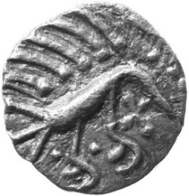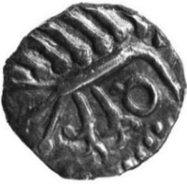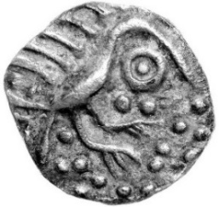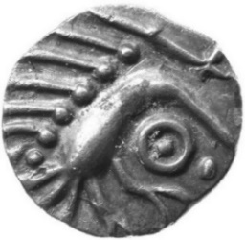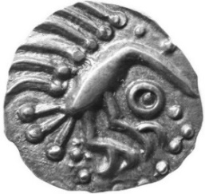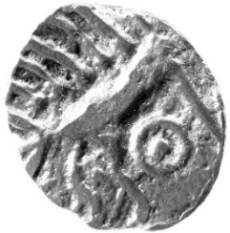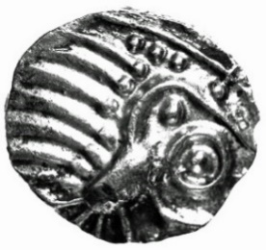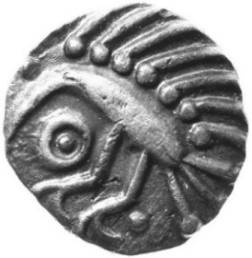
reverses:
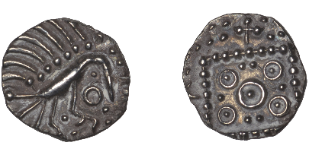
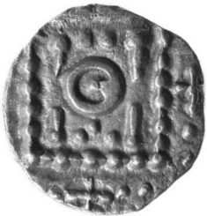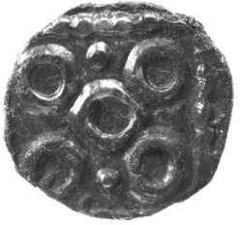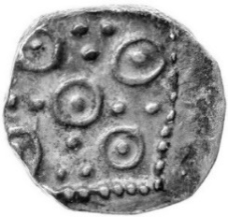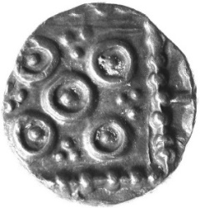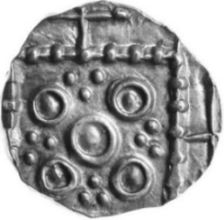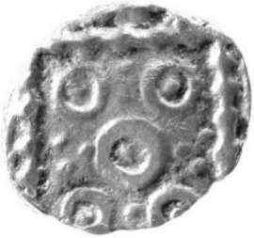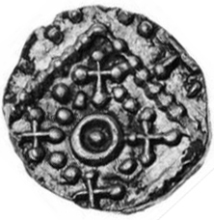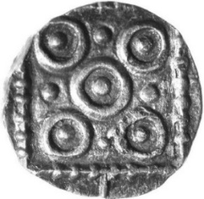
Courtesy of Noonans, 9th March 2023:
VICO
Some obverses:
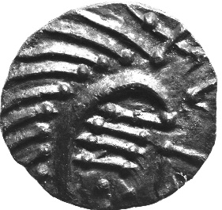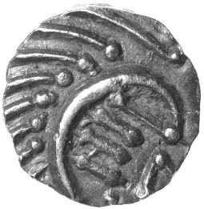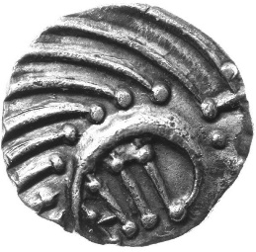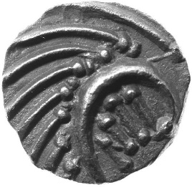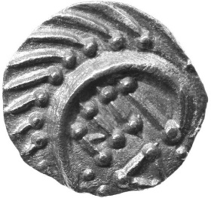
reverses:
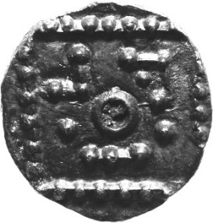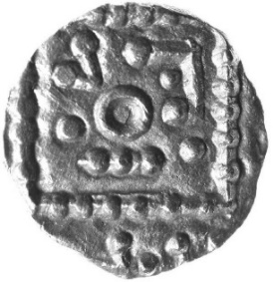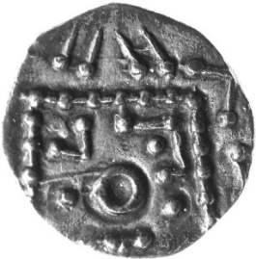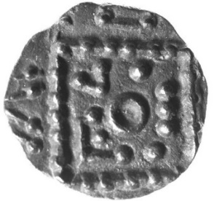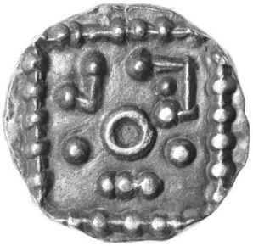

Mules:
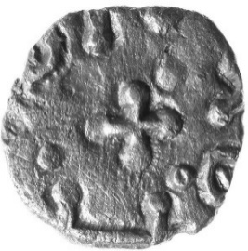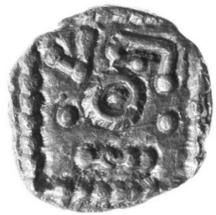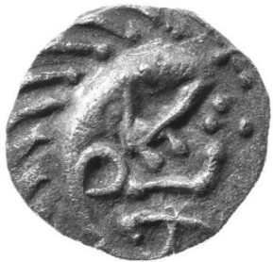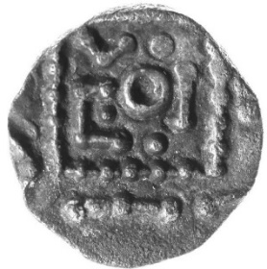

VARIETY G
Some obverses:
G1: G2: G3: G4:
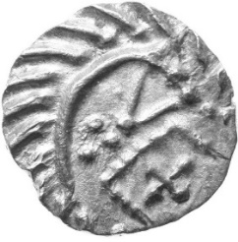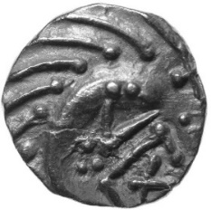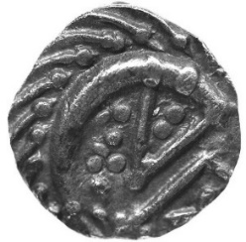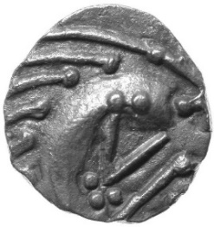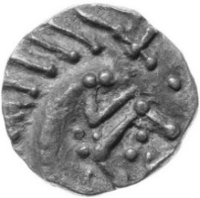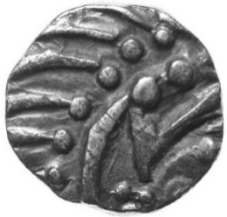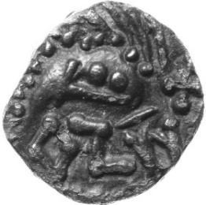
Reverses:
G1: G1-G4:
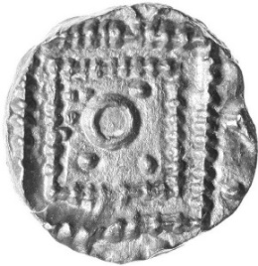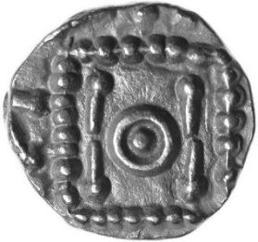
G5: G5 reverses:
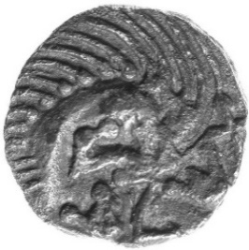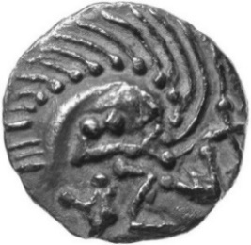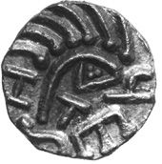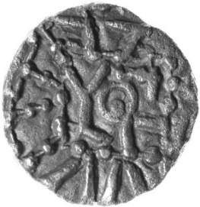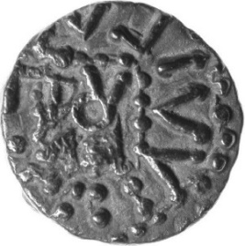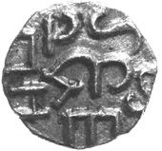

VARIETY D
Generally, the foot of the ‘porcupine’ is an annulet.
Some obverses:
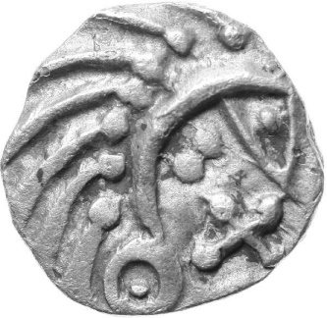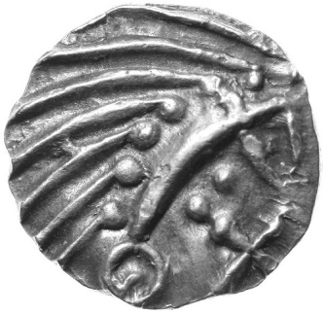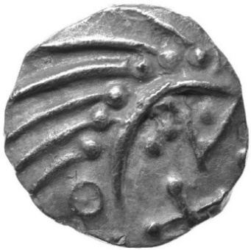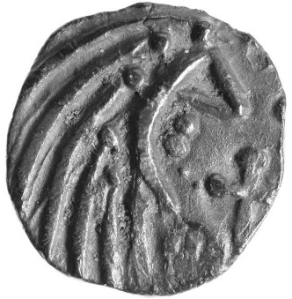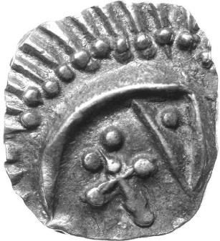
Reverses:
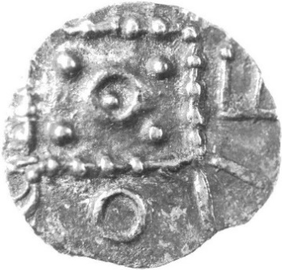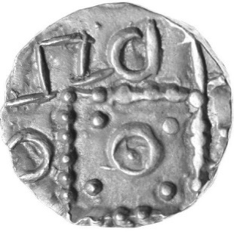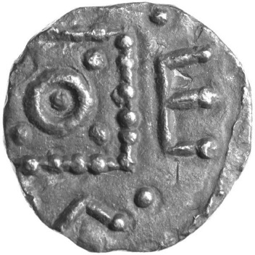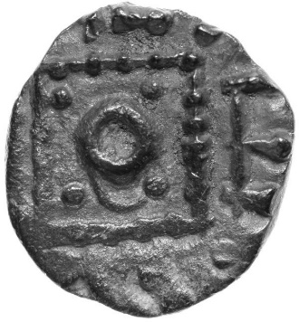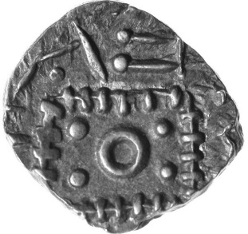
Variant
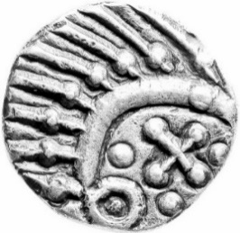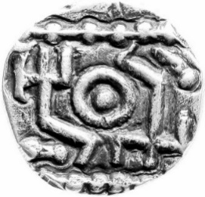

SECONDARY PHASE
VARIETY A
Some obverses: Variants:
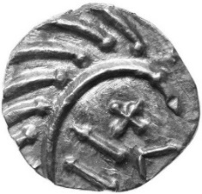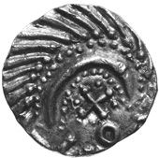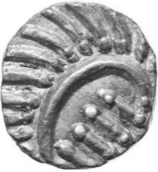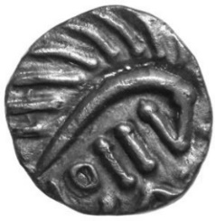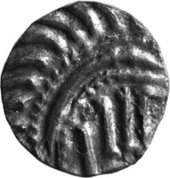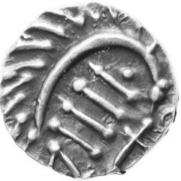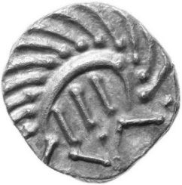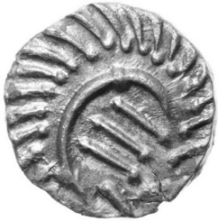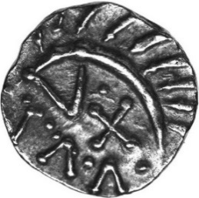
reverses: Variants:
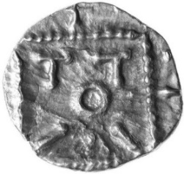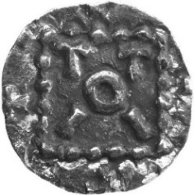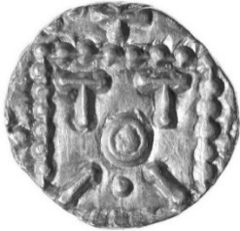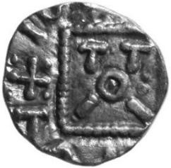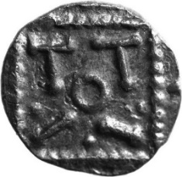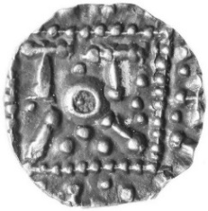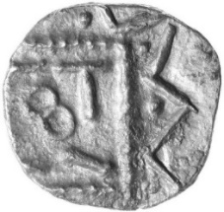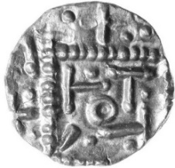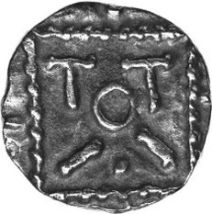

SUB-VARIETY DIE GRAPHICS
Other than variety A, the secondary dies are represented by line drawings from Op den Velde and Metcalf (JMP97). These are not linked to the Abramson auction.
Select the ‘DIE GRAPHIC’ nearest to your specimen (all are reverses other than sub-variety h). Note the reference number and select Find in the tool bar. Enter the number in the Navigation panel to locate the ‘DETAIL GRAPHICS’, at the foot of the document. This gives information about related specimens and the find place of the illustrated line drawing. References are to Op den Velde and Metcalf. Use the Navigation panel to return to the ‘DIE GRAPHICS’.
Only the specimens illustrated in the JMP97 corpus are referenced. Illustrated sceats are representative of the variety.
Dies are arranged approximately by the extent of deterioration from the ToTII ‘votive standard’. Diamond reverses are shown separately.
ToTII ‘VOTIVE STANDARD’ REVERSES
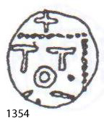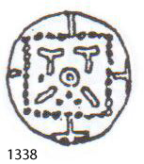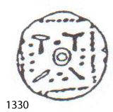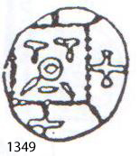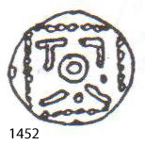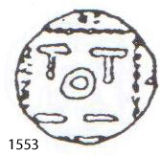
1354 1338 1330 1349 1452 1553
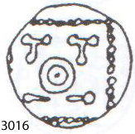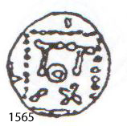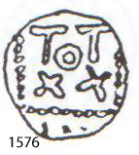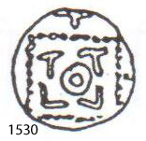
3016 1565 1576 1530

ToTII ‘VOTIVE STANDARD’ REVERSES (continued)
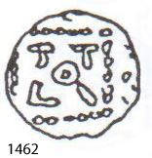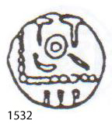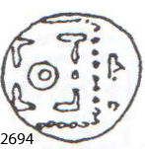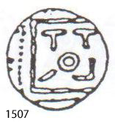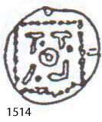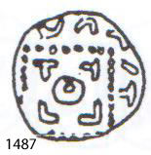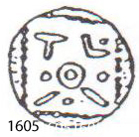
1462 1532 2694 1507 1514 1487 1605
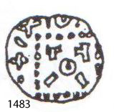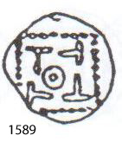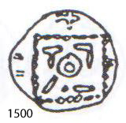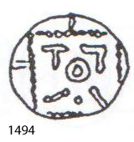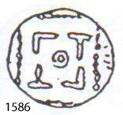
1483 1589 1500 1494 1586
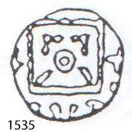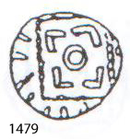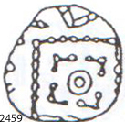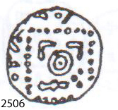
1535 1479 2459 2506
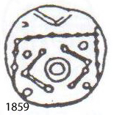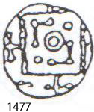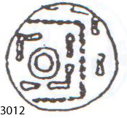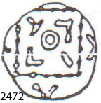
1859 1477 3012 2472
ToTII ‘VOTIVE STANDARD’ REVERSES (continued)
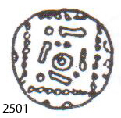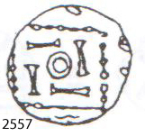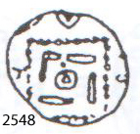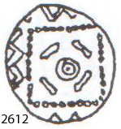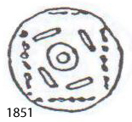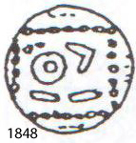
2501 2557 2548 2612 1851 1848
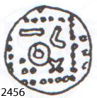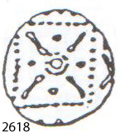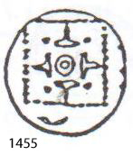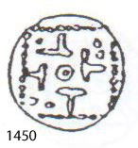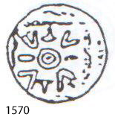
1456 2618 1455 1450 1570
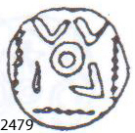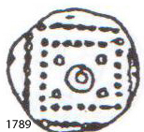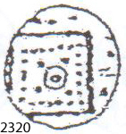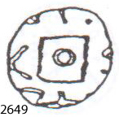
2479 1789 2320 2649
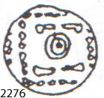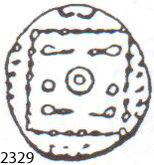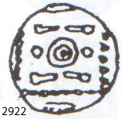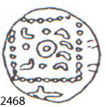
2276 2329 2468 2922

DIAMOND REVERSES
This section includes dies which are more symmetrical if viewed as a diamond usually with the cross uppermost. These are arranged according to increasing complexity of design.
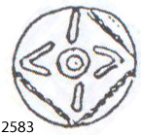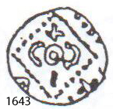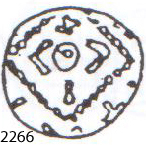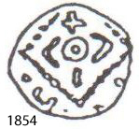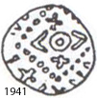
2583 1643 2266 1854 1941
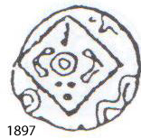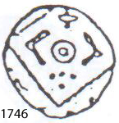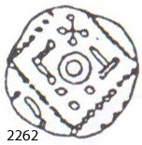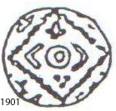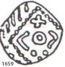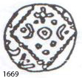
1897 1746 2262 1901 1659 1669
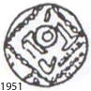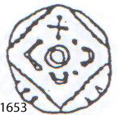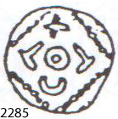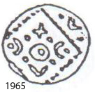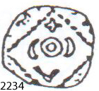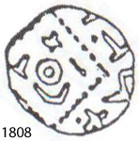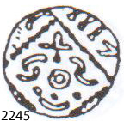
1951 1653 2285 1965 2234 1808 2245

DIAMOND REVERSES (continued)
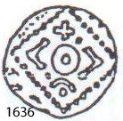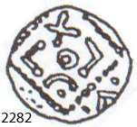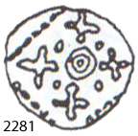
1636 2282 2281
VICO variant:
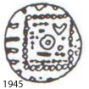
1945

SUB-VARIETY h
OBVERSES
These typically have an annulet touching the ‘nose’ of the ‘porcupine’.
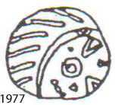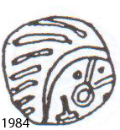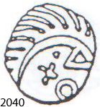
1977 1984 2022 2040
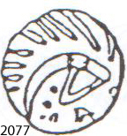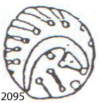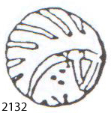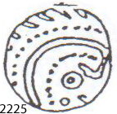
2077 2095 2132 2225

TERTIARY PHASE
VARIETY B
Some obverses:
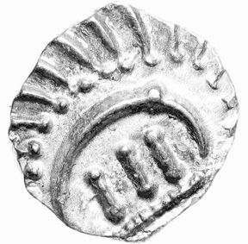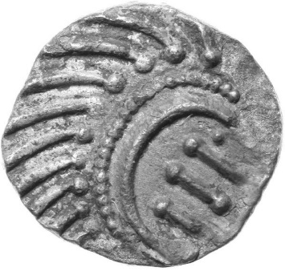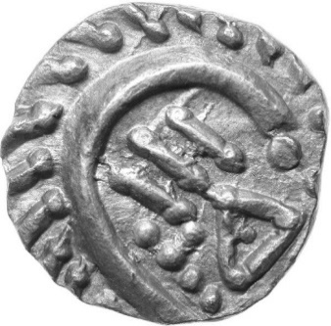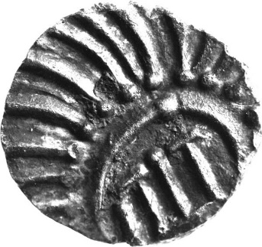
Some reverses:
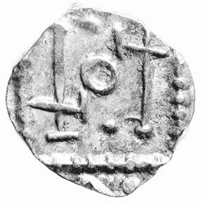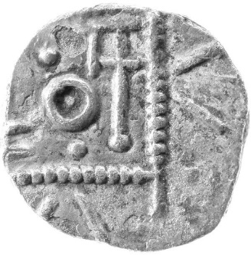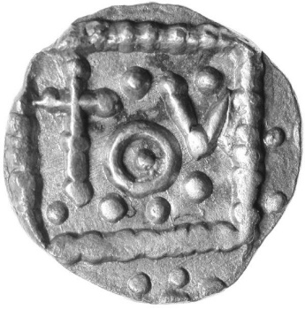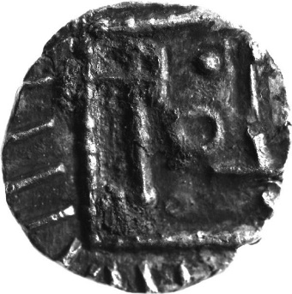

VARIETY E
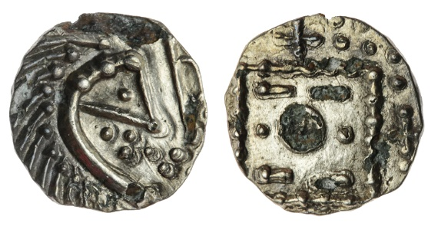
2922
VARIETY F
Some obverses:
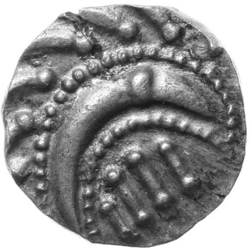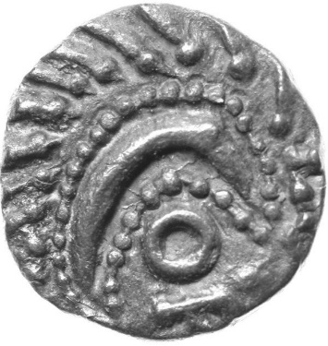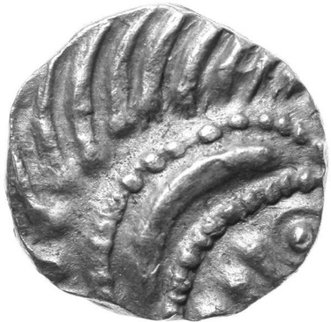
Some reverses:
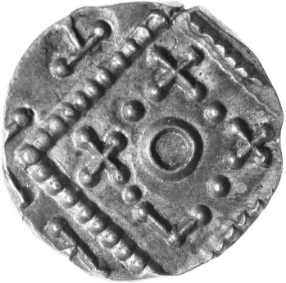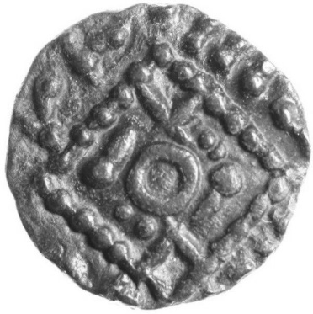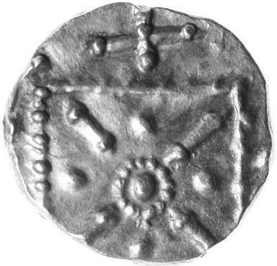

OBSERVATIONS
I tested a sample of secondary types in my auction against the line drawings in this document and I found about half. Even then, the obverses were often different. This demonstrates that JMP97 is far from complete (only die-linked specimens are illustrated) and that the coinage production was too chaotic to capture simplistically. One is reminded of Northumbrian stycas.
HYPOTHESIS
Op den Velde and Metcalf estimate a total of over 5,300 reverse dies (excluding primary imitations), extrapolating to around 55 million sceats for the entire Series E coinage, 76% of which was in the secondary phase. They assume an optimistic 10,000 strikes per die and no material shortages. Even if it were only half this number, production demands in the secondary phase clearly led to chaotic mixing of obverse and reverse dies – there could have been over 10 million obverse/reverse die combinations in this phase. On the other hand, there is a distinct lack of obverse/obverse and reverse/reverse mules, so some degree of control must have been exercised.
As regards who produced Series E, I suggest it is a mercantile rather than regal currency, otherwise the mighty Radbod would have had his name on the coins. Besides, possibly it is intentionally anonymous to encourage wider use - by both Christian and pagan traders. It is not dominated by crosses but often has them alongside other symbols. Perhaps it is fanciful to suggest that, while it may have been produced (peripatetically?) by a group of engravers and mint workers ('the mint'), it was subsidised by individual merchants belonging to a trading guild. As long as they adhered to the metrology and generic designs of ‘porcupine’ and degenerate votive standard, they could improvise their own anepigraphic motifs, and supply ‘the mint’ with silver for production of their own “signature” sceats. Probably total rubbish!
ACKNOWLEDGEMENTS
Many thanks to Wybrand Op den Velde for image use permission. Thanks also to Ype de Jong for inspiring this approach.
DETAIL GRAPHICS
SUB-VARIETY d
1330
Series: | E
Phase: | secondary
Sub-variety: | d
JMP97: | 1330-36
SL group: | 95
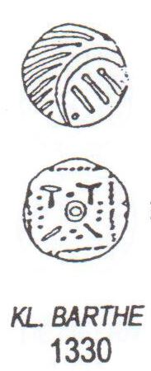

1338
Series: | E
Phase: | secondary
Sub-variety: | d
JMP97: | 1337-38
SL group: | 95
Variants: | 1360-63, 1395-95, 1436 and 1444 have no pellets/trefoil.  1364-65, 1391-92, 1419, 1478 and 1504 have no pellet on the left.  1373-79, 1389-90, 1418, 1402-3, 1433, 1435 and 1445-46 have a single pellet below.  1404-05 have a single pellet below and either side.  1383-84 have the lower left symbol duplicated.  1505 has a trefoil below and right.
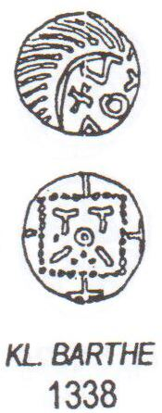

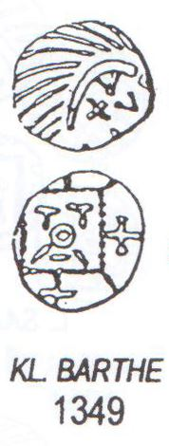
1349
Series: | E
Phase: | Secondary
Sub-variety: | D
JMP97: | 1349-50
SL group: | 95
Variants: | 1341-44 have no bar below the central annulet

Series: | E
Phase: | secondary
Sub-variety: | d
JMP97: | 1354-55
SL group: | 95
1354
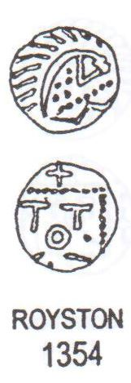
Series: | E
Phase: | secondary
Sub-variety: | d
JMP97: | 1450-51
SL group: | 95
Variants: | 1447-49 have no pellets.  See 1454-56 below
1450
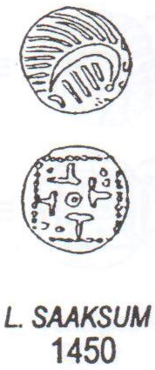
1452
Series: | E
Phase: | secondary
Sub-variety: | d
JMP97: | 1452-53
SL group: | 95
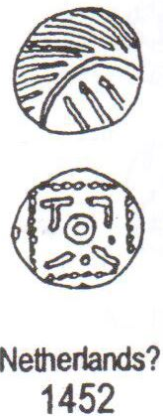
Series: | E
Phase: | secondary
Sub-variety: | d
JMP97: | 1454-56
SL group: | 95
Variants: | 1447-49 have no pellets.  See 1447-51 above
1455
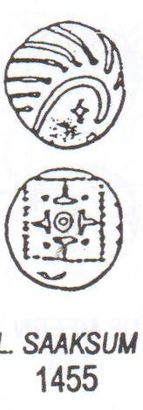

1462
Series: | E
Phase: | secondary
Sub-variety: | d
JMP97: | 1462-63
SL group: | 95
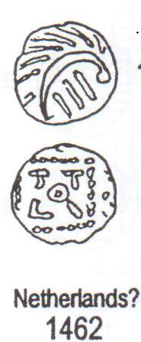
1477
Series: | E
Phase: | secondary
Sub-variety: | d
JMP97: | 1477
SL group: | 95
Variants: | 1386
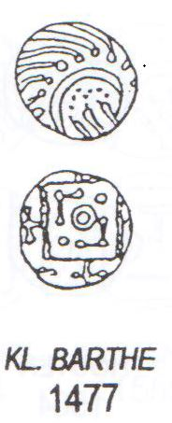
1479
Series: | E
Phase: | secondary
Sub-variety: | d
JMP97: | 1479
SL group: | 95
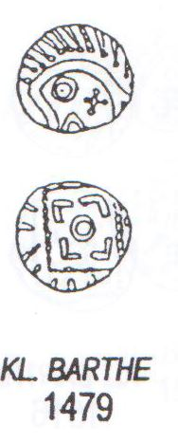
1483
Series: | E
Phase: | secondary
Sub-variety: | d
JMP97: | 1483-84
SL group: | 95
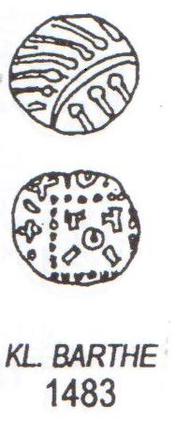
1487
Series: | E
Phase: | secondary
Sub-variety: | d
JMP97: | 1486-87
SL group: | 95
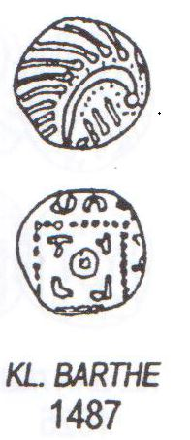
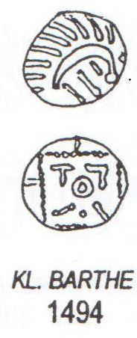
1494
Series: | E
Phase: | secondary
Sub-variety: | d
JMP97: | 1494-95
SL group: | 95
Variant: | 1499 has a pellet between symbols

1500
Series: | E
Phase: | secondary
Sub-variety: | d
JMP97: | 1500
SL group: | 95
Variant: | 1387
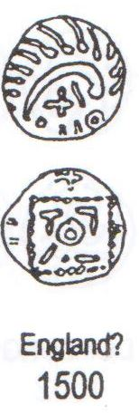
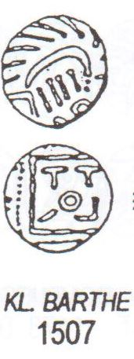
1507
Series: | E
Phase: | secondary
Sub-variety: | d
JMP97: | 1506-26
SL group: | 95
Variants: | 1470-73 lower symbols reversed.  1513-16 have a pellet between symbols.

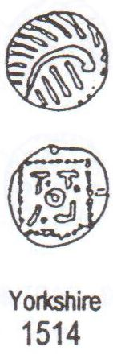
1514
Series: | E
Phase: | secondary
Sub-variety: | d
JMP97: | 1513-16
SL group: | 95
Variants: | 1506-08 and 1518-26 have no pellets

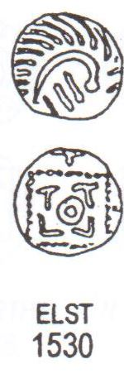
1530
Series: | E
Phase: | secondary
Sub-variety: | d
JMP97: | 1529-30
SL group: | 95

Series: | E
Phase: | secondary
Sub-variety: | d
JMP97: | 1532-33
SL group: | 95
1532
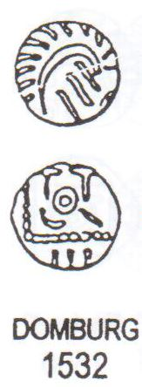

Series: | E
Phase: | secondary
Sub-variety: | d
JMP97: | 1535-36
SL group: | 95
Variants: | 1540-41 have a T top left.  1562-64 have a pellet below and right
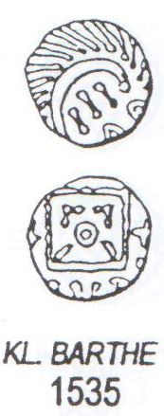
1535

1553

Series: | E
Phase: | secondary
Sub-variety: | d
JMP97: | 1553-56
SL group: | 95
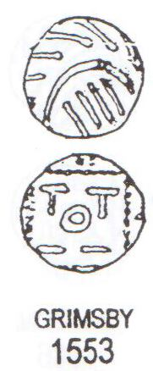
1565
Series: | E
Phase: | secondary
Sub-variety: | d
JMP97: | 1565-67
SL group: | 95
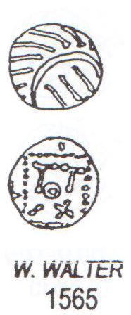
1570
Series: | E
Phase: | secondary
Sub-variety: | d
JMP97: | 1570-71
SL group: | 95
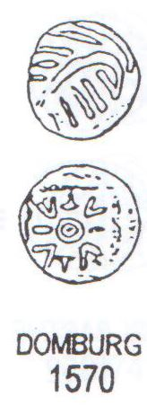
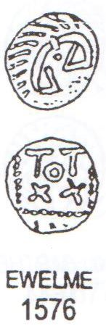
1576
Series: | E
Phase: | secondary
Sub-variety: | d
JMP97: | 1576-77
SL group: | 95

1586
Series: | E
Phase: | secondary
Sub-variety: | d
JMP97: | 1584-86
SL group: | 95
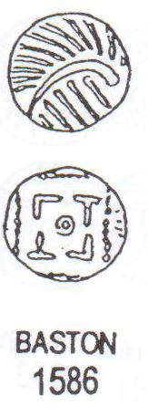
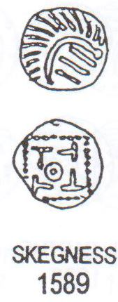
1589
Series: | E
Phase: | secondary
Sub-variety: | d
JMP97: | 1589-90
SL group: | 95

Series: | E
Phase: | secondary
Sub-variety: | d
JMP97: | 1605-06
SL group: | 95
Variants: | 1608-09 have diamond reverses
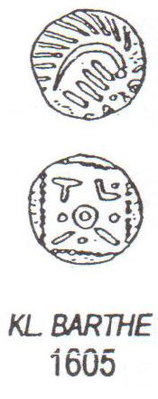
1605

SUB-VARIETY e
Series: | E
Phase: | secondary
Sub-variety: | e
JMP97: | 1633-37
SL group: | 96
Variants: | 1682-90, 1728
1636

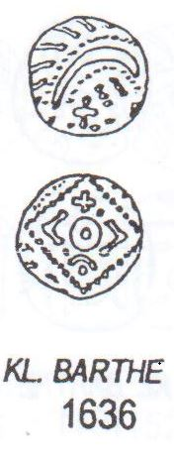

Series: | E
Phase: | secondary
Sub-variety: | e
JMP97: | 1642-45
SL group: | 96
Variants: | 1658, 1664, 1699-1700, 1706-18, 1674-77.
1643
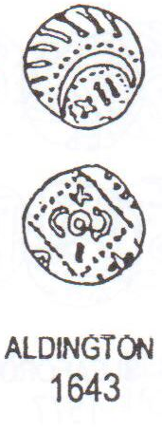
Series: | E
Phase: | secondary
Sub-variety: | e
JMP97: | 1652-54
SL group: | 96
Variants: | 1670-72, 1680-81, 1720-21.
1653

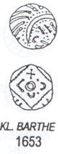
Series: | E
Phase: | secondary
Sub-variety: | e
JMP97: | 1659-62
SL group: | 96
Variants: | 1665, 1725-7, 1734-44.
1659

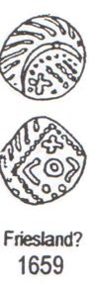
Series: | E
Phase: | secondary
Sub-variety: | e
JMP97: | 1668-9
SL group: | 96

1669
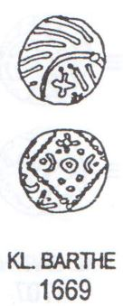
Series: | E
Phase: | secondary
Sub-variety: | e
JMP97: | 1746-77
SL group: | 96
1746

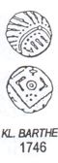
Series: | E
Phase: | secondary
Sub-variety: | e
JMP97: | 1761-92
SL group: | 96
1789

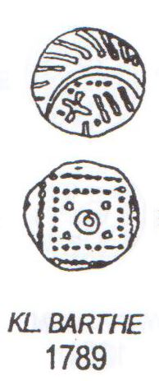
SUB-VARIETY f
1808
Series: | E
Phase: | secondary
Sub-variety: | f
JMP97: | 1805-23
SL group: | 97

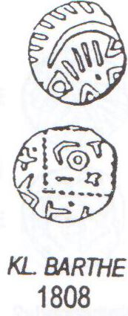

Series: | E
Phase: | secondary
Sub-variety: | f
JMP97: | 1824-49
SL group: | 97
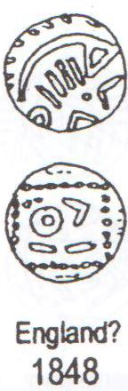
1848

1851
Series: | E
Phase: | secondary
Sub-variety: | f
JMP97: | 1851
SL group: | 97
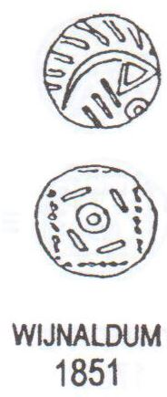

1854
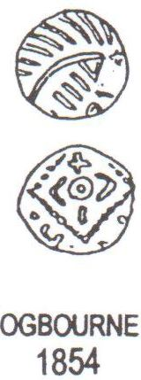

Series: | E
Phase: | secondary
Sub-variety: | f
JMP97: | 1854
SL group: | 97
Variants: | 1852 has a chevron above, as have 1853 and 1855, but with a trefoil below. 1856 also has a trefoil below.

Series: | E
Phase: | secondary
Sub-variety: | f
JMP97: | 1858-92
SL group: | 97
Variants: | 1893-96 have two additional pellets.
1859
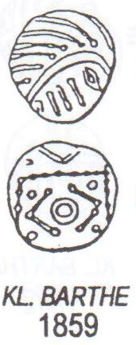

SUB-VARIETY g
1897
Series: | E
Phase: | secondary
Sub-variety: | g
JMP97: | 1897
SL group:
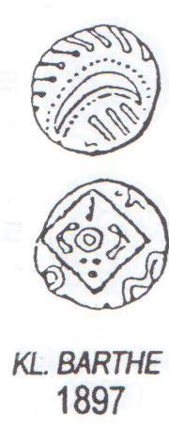

1901
Series: | E
Phase: | secondary
Sub-variety: | g
JMP97: | 1898-1916
SL group:
Variants: | 1921-24
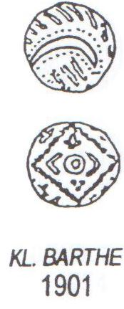

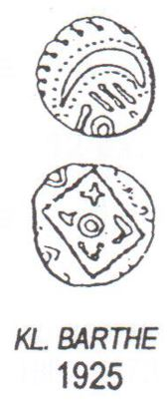
1925
Series: | E
Phase: | secondary
Sub-variety: | g
JMP97: | 1940-41
SL group:

Series: | E
Phase: | secondary
Sub-variety: | g
JMP97: | 1940-41
SL group:
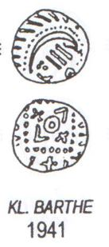1941

Series: | E
Phase: | secondary
Sub-variety: | g
JMP97: | 1945-47
SL group:

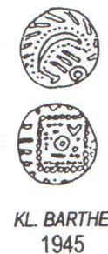1945

Series: | E
Phase: | secondary
Sub-variety: | g
JMP97: | 1950-51
SL group:

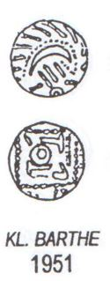1951

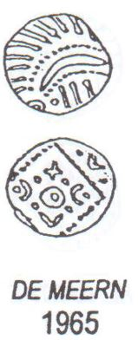1965
Series: | E
Phase: | secondary
Sub-variety: | g
JMP97: | 1958-65
SL group:

SUB-VARIETY h
1977
Series: | E
Phase: | secondary
Sub-variety: | h
JMP97: | 1971-2017
SL group:
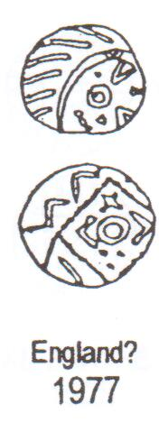

Series: | E
Phase: | secondary
Sub-variety: | h
JMP97: | 1980-87
SL group:
Variants: | 2061-62

1984

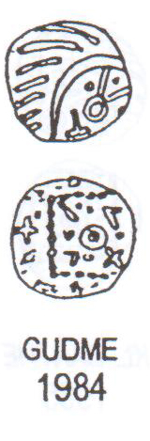

Series: | E
Phase: | secondary
Sub-variety: | h
JMP97: | 2021-35
SL group:
Variants: | 2042-47, 2081-92, 2101-31, 2150-90.
2022
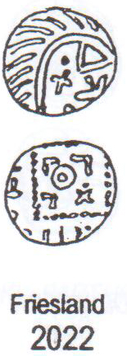

Series: | E
Phase: | secondary
Sub-variety: | h
JMP97: | 2036-41
SL group:
Variants: | 1968-70, 2049-60, 2063-64, 2071-74, 2135-48.

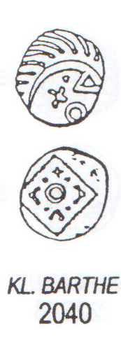
2040
Series: | E
Phase: | secondary
Sub-variety: | h
JMP97: | 2076-80
SL group:
2077

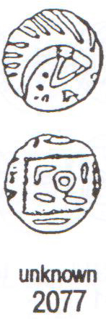
Series: | E
Phase: | secondary
Sub-variety: | h
JMP97: | 2093-96
SL group:
2095

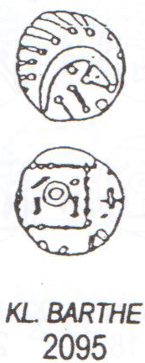
Series: | E
Phase: | secondary
Sub-variety: | h
JMP97: | 2132-34
SL group:
2132

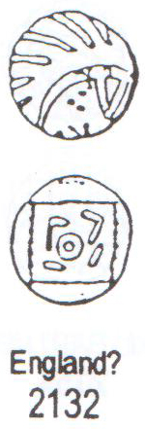
Series: | E
Phase: | secondary
Sub-variety: | h
JMP97: | 2193-2226
SL group:
2225
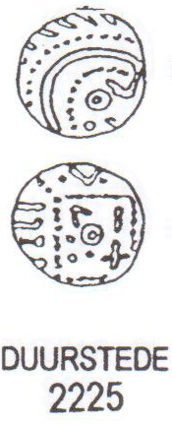

SUB-VARIETY i
Series: | E
Phase: | secondary
Sub-variety: | i
JMP97: | 2234-42
SL group:
2234
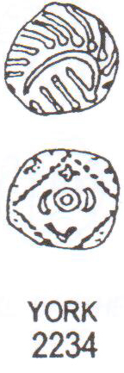

2245
Series: | E
Phase: | secondary
Sub-variety: | i
JMP97: | 2245-6
SL group:

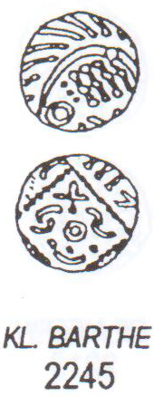
2262
Series: | E
Phase: | secondary
Sub-variety: | i
JMP97: | 2251-63
SL group:

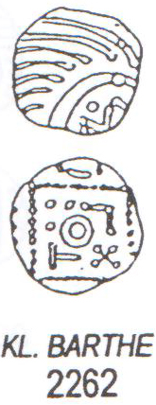
2266
Series: | E
Phase: | secondary
Sub-variety: | i
JMP97: | 2265-6
SL group:

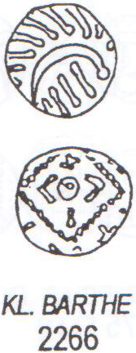
2282
Series: | E
Phase: | secondary
Sub-variety: | i
JMP97: | 2282
SL group:

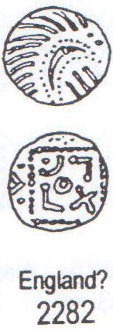
Series: | E
Phase: | secondary
Sub-variety: | i
JMP97: | 2284-5
SL group:
2285
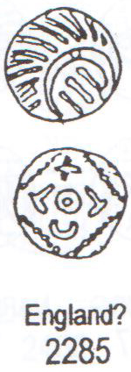
2281
Series: | E
Phase: | secondary
Sub-variety: | i
JMP97: | 2281
SL group:
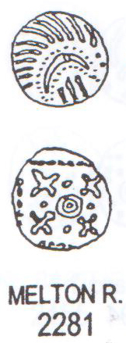

2276
Series: | E
Phase: | secondary
Sub-variety: | i
JMP97: | 2275-6
SL group:
Variants: | Variety G3 and variety E, 2922-3011
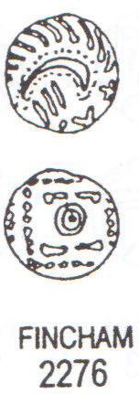

SUB-VARIETY k
Series: | E
Phase: | secondary
Sub-variety: | k
JMP97: | 2309-20
SL group: | 97
2320

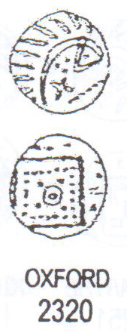

Series: | E
Phase: | secondary
Sub-variety: | k
JMP97: | 2328-9
SL group:
Variants: | Variety G3, sub-variety a 727-51, variety D 637-716 and sub-variety e 1761-92  Variety E, 2922-3011.
2329
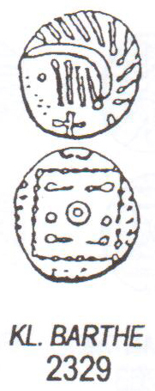
2456
Series: | E
Phase: | secondary
Sub-variety: | k
JMP97: | 2455-6
SL group: | 97
Variants: | Sub-variety i, 2251-66
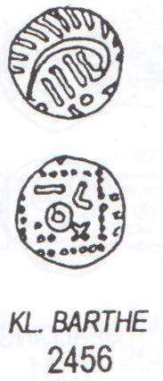

2459
Series: | E
Phase: | secondary
Sub-variety: | k
JMP97: | 2459-61
SL group:
Variants: | Sub-variety d 1479

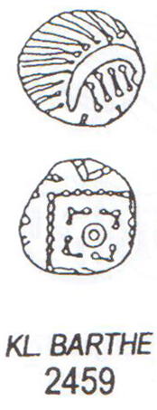
2468
Series: | E
Phase: | secondary
Sub-variety: | k
JMP97: | 2467-9
SL group: | 97
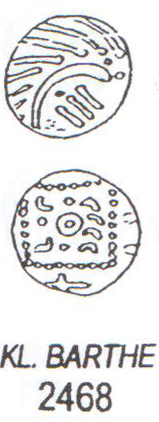

2472
Series: | E
Phase: | secondary
Sub-variety: | k
JMP97: | 2472-4
SL group:
Variants: | 2647-8

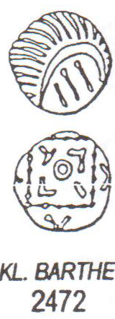
2479
Series: | E
Phase: | secondary
Sub-variety: | k
JMP97: | 2478-81
SL group:
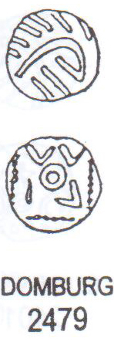

2501
Series: | E
Phase: | secondary
Sub-variety: | k
JMP97: | 2501-2
SL group:
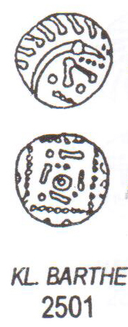

2506
Series: | E
Phase: | secondary
Sub-variety: | k
JMP97: | 2505-06
SL group:

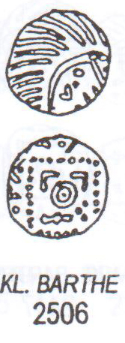

Series: | E
Phase: | secondary
Sub-variety: | k
JMP97: | 2532-57
SL group:
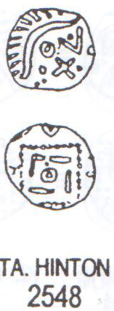
2548

2557
Series: | E
Phase: | secondary
Sub-variety: | k
JMP97: | 2527-57
SL group:
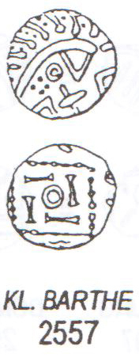

2583
Series: | E
Phase: | secondary
Sub-variety: | k
JMP97: | 2564-98
SL group: | 96
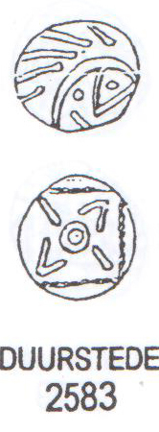

2612
Series: | E
Phase: | secondary
Sub-variety: | k
JMP97: | 2611-12
SL group:

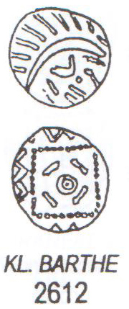

Series: | E
Phase: | secondary
Sub-variety: | k
JMP97: | 2614-2630
SL group:
Variants: | 2651-2
2618
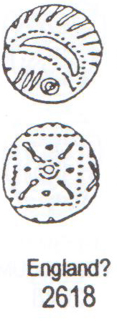
2649
Series: | E
Phase: | secondary
Sub-variety: | k
JMP97: | 2649-50
SL group: | 100

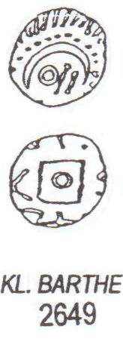
2694
Series: | E
Phase: | secondary
Sub-variety: | k
JMP97: | 2692-4
SL group:
Variants: | Sub-variety d, 1529-30

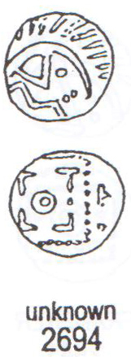
TERTIARY – VARIETY E
2922
Series: | E
Phase: | tertiary
Variety: | E
JMP97: | 2922-3011
SL group: | 99
Variants: | Variety G3 and sub-variety a 727-51, variety D 637-716, sub-variety e 1761-92 and Variety E 2328-9.
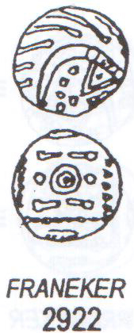

Series: | E
Phase: | tertiary
Variety: | E
JMP97: | 2328-9
SL group:
Variants: | Sub-variety a 727-51, variety D 637-716 and sub-variety e 1761-92  Variety E, 2922-3011.
3000

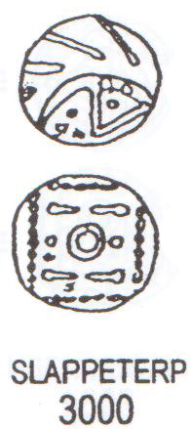
3012
Series: | E
Phase: | tertiary
Variety: | E2
JMP97:
SL group:

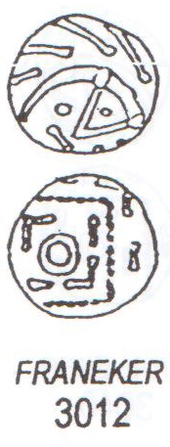
3116
Series: | E
Phase: | tertiary
Sub-variety: | AF
JMP97:
SL group:
